18ECC102J – ELECTRONIC DEVICES LABORATORY

CIRCUIT OUTPUTS

EXPERIMENT 1

VI CHARACTERISTICS OF PN JUNCTION DIODE

CIRCUIT DIAGRAM:

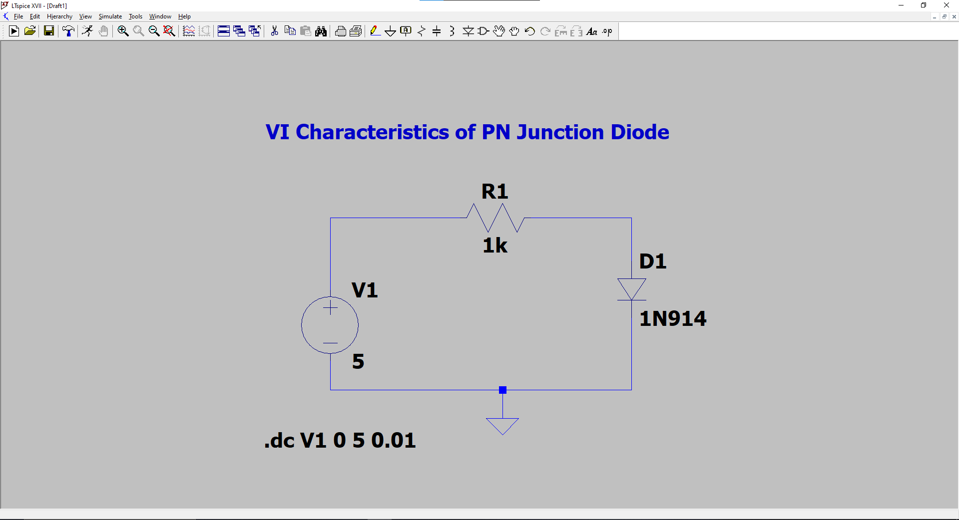

FORWARD BIAS CHARACTERISTICS:

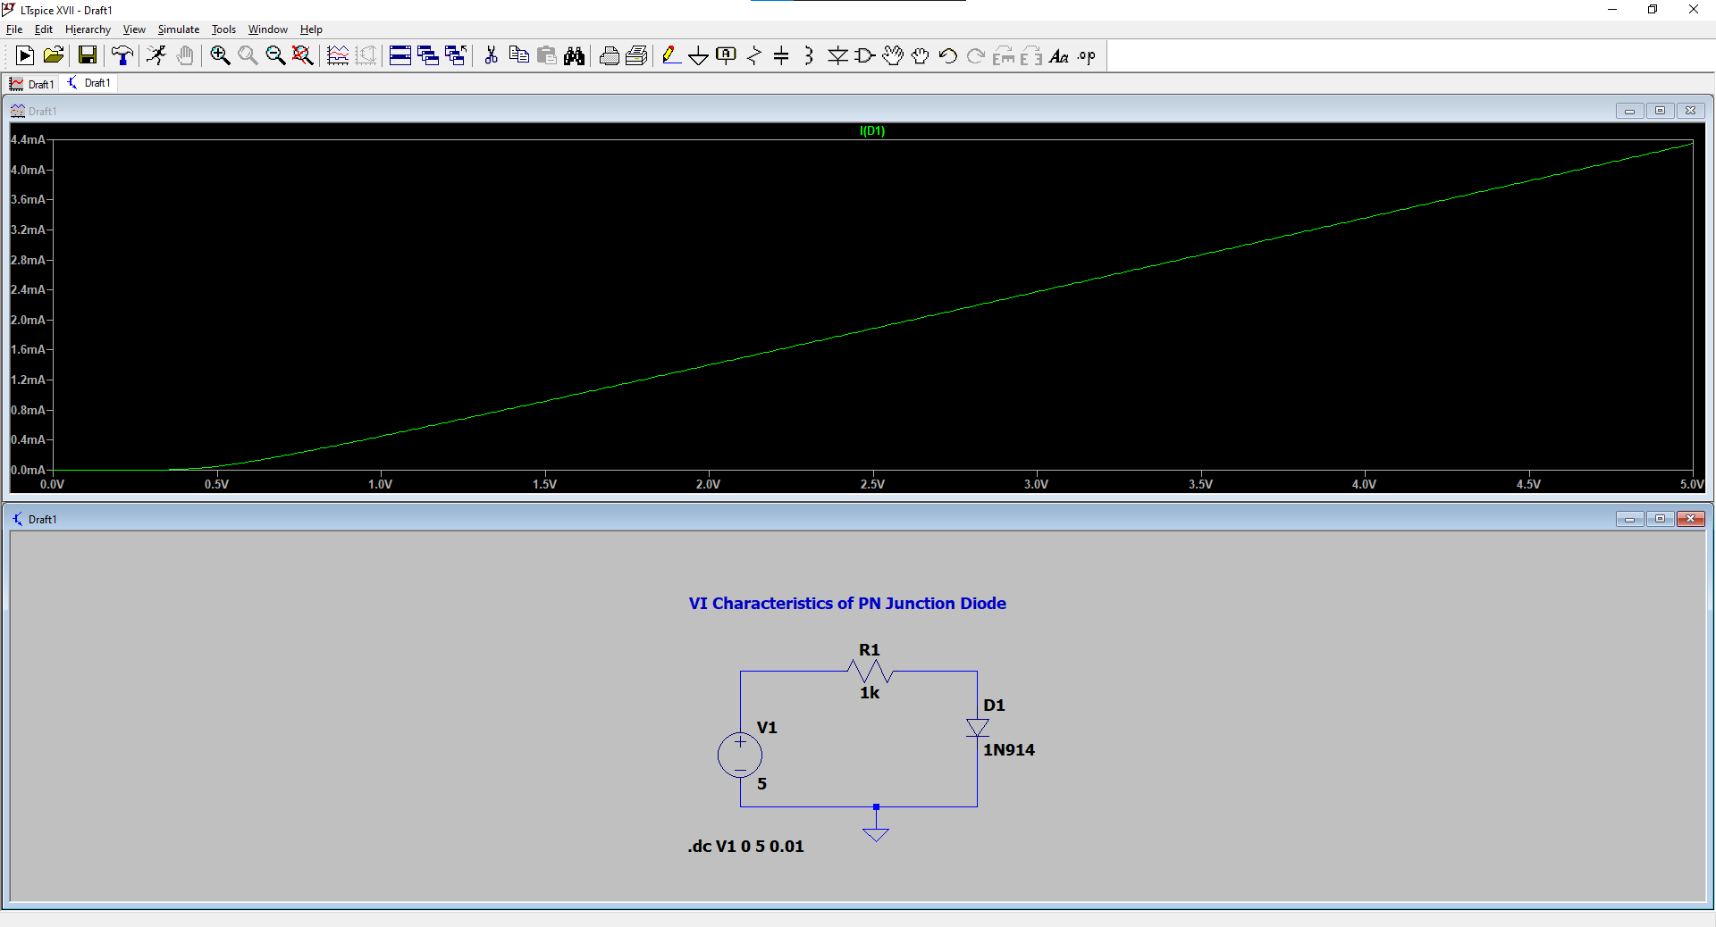

REVERSE BIAS CHARACTERISTICS:

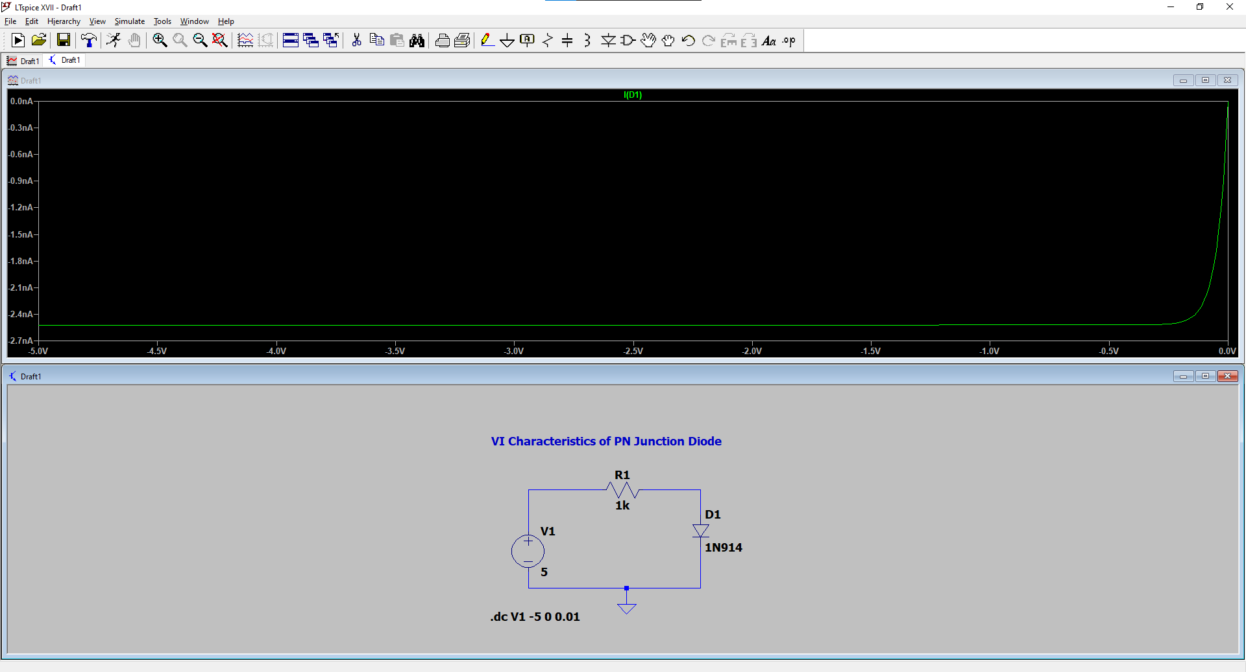

18ECC102J – ELECTRONIC DEVICES LABORATORY

CIRCUIT OUTPUTS

EXPERIMENT 2

ZENER DIODE CHARACTERISTICS

FORWARD BIAS CHARACTERISTICS:

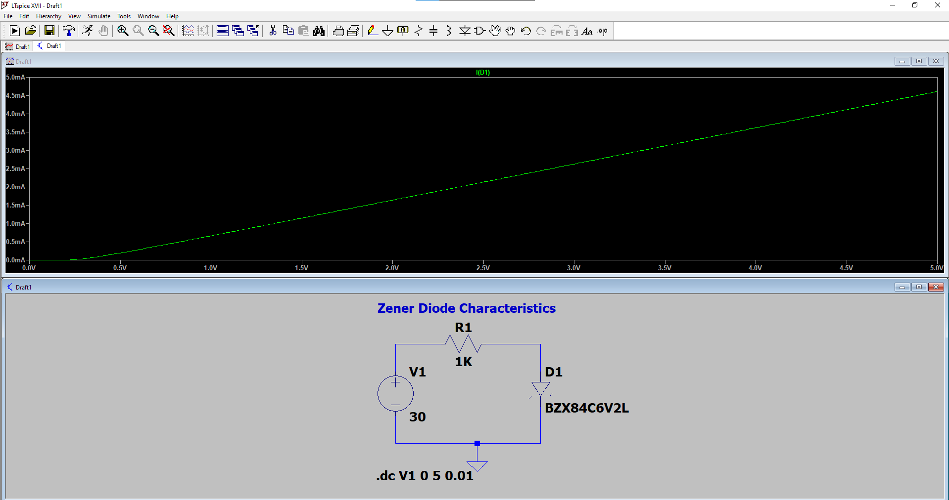

REVERSE BIAS CHARACTERISTICS:

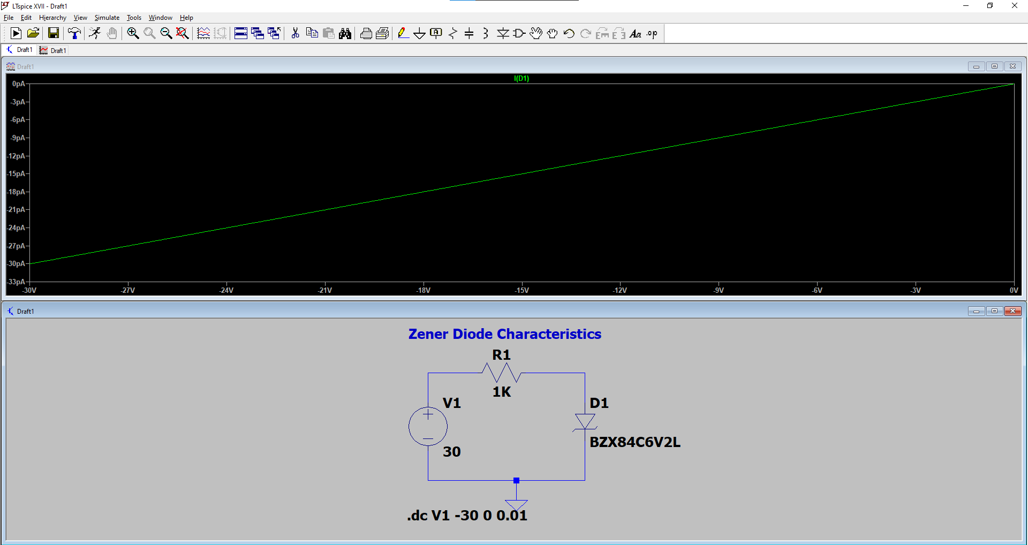

18ECC102J – ELECTRONIC DEVICES LABORATORY

CIRCUIT OUTPUTS

EXPERIMENT 3

RECTIFIERS.

HALF WAVE RECTIFIER

INPUT WAVEFORM:

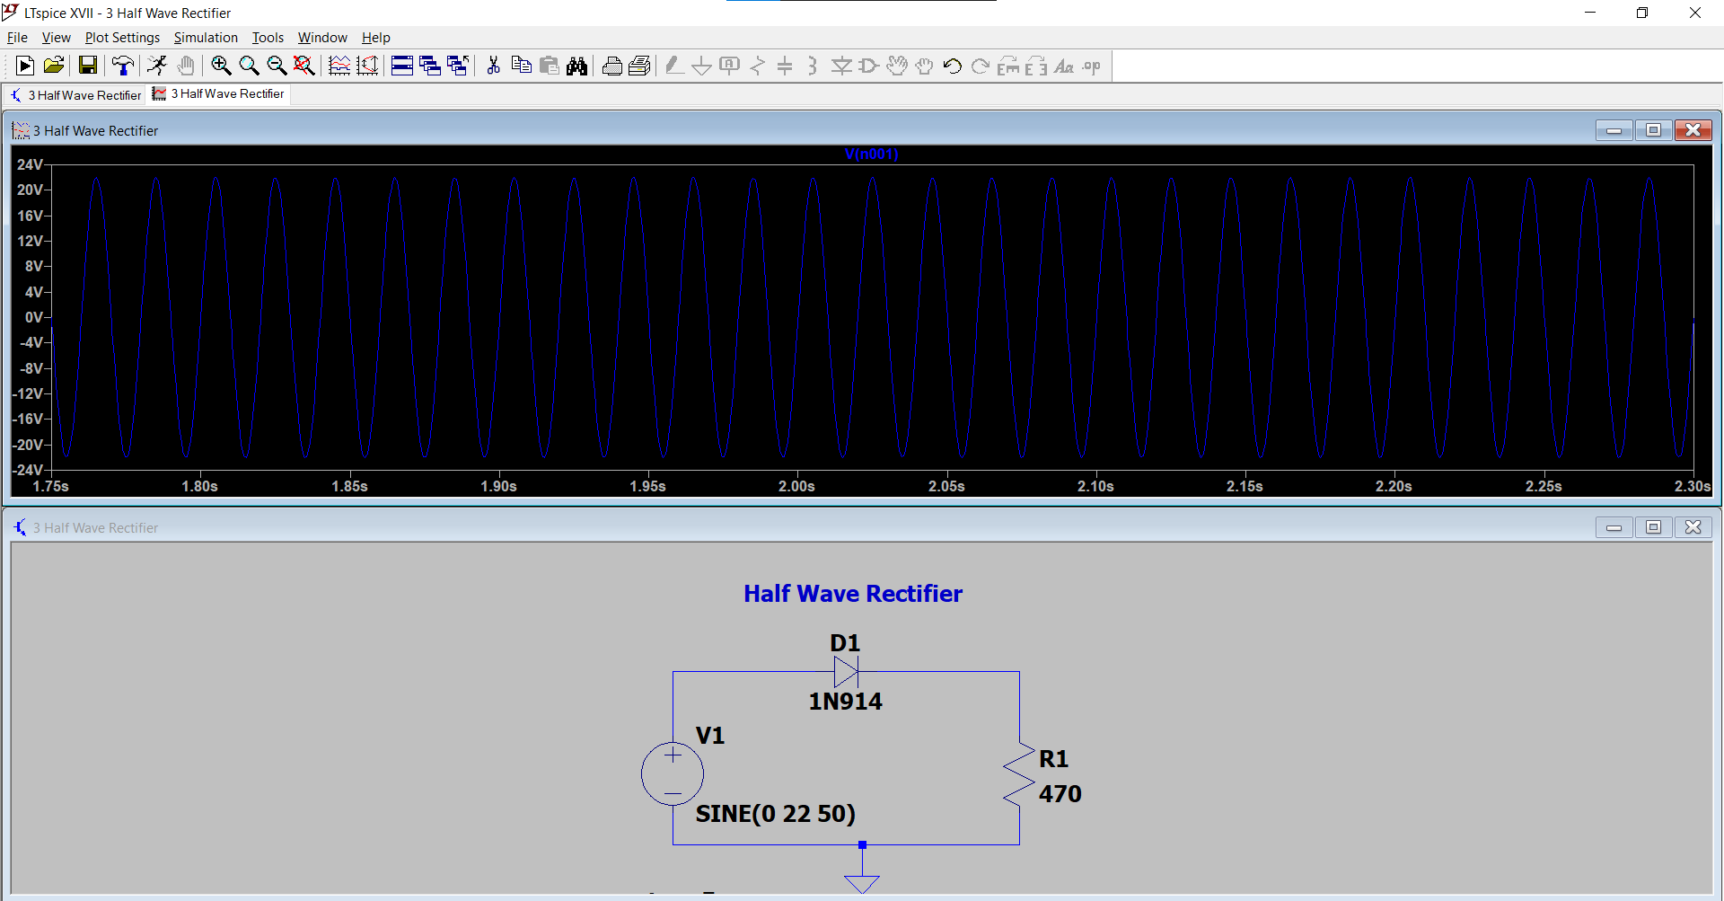

OUTPUT WAVEFORM WITHOUT FILTER:

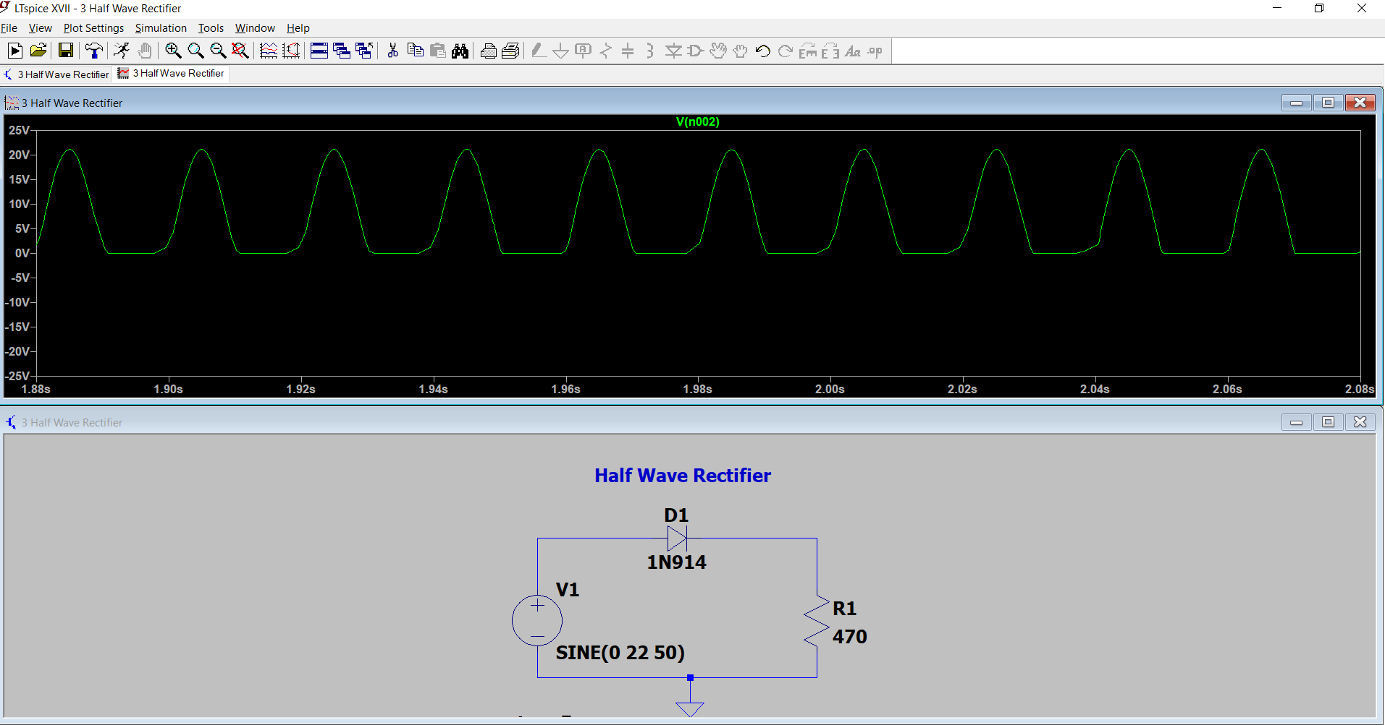

OUTPUT WAVEFORM WITH FILTER:

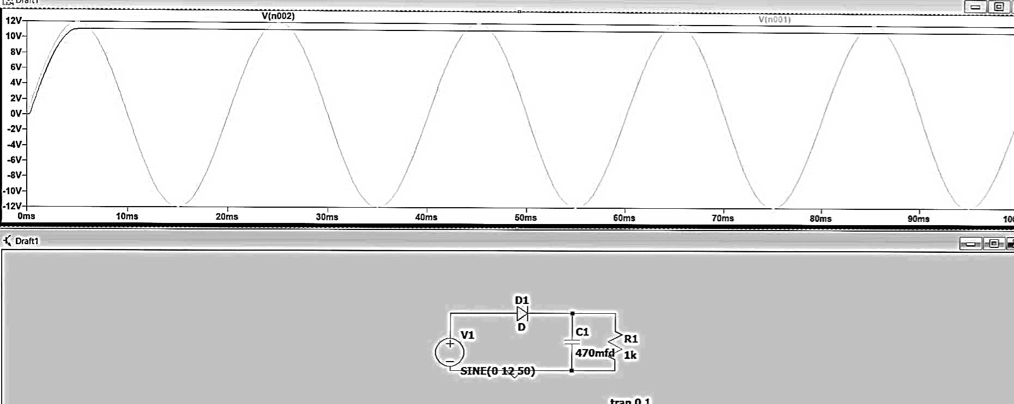

FULL WAVE RECTIFIER

OUTPUT WAVEFORM WITHOUT FILTER:

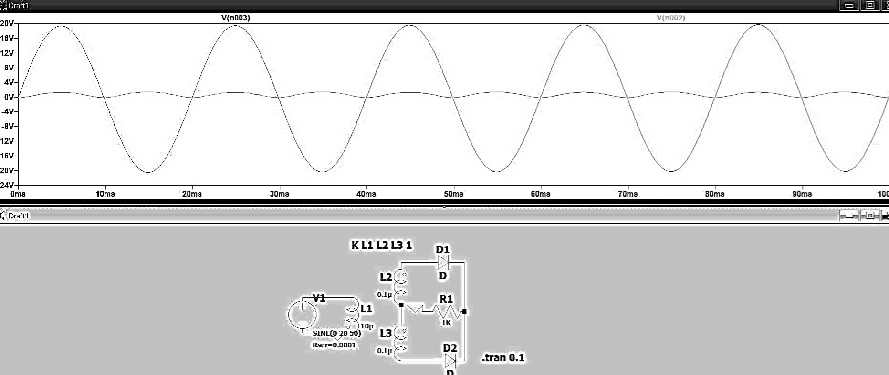

OUTPUT WAVEFORM WITH FILTER:

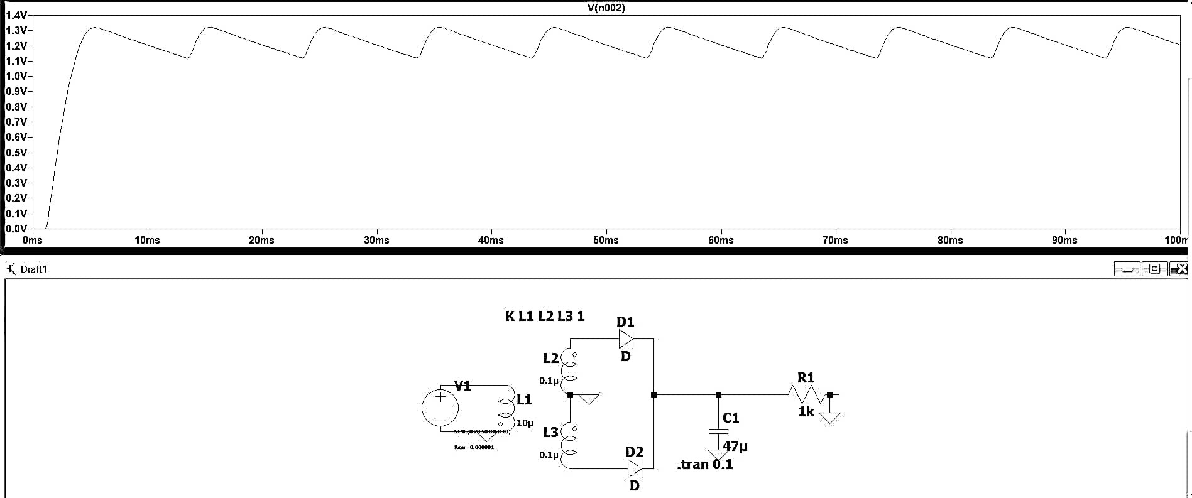

BRIDGE RECTIFIER

OUTPUT WAVEFORM WITHOUT FILTER:

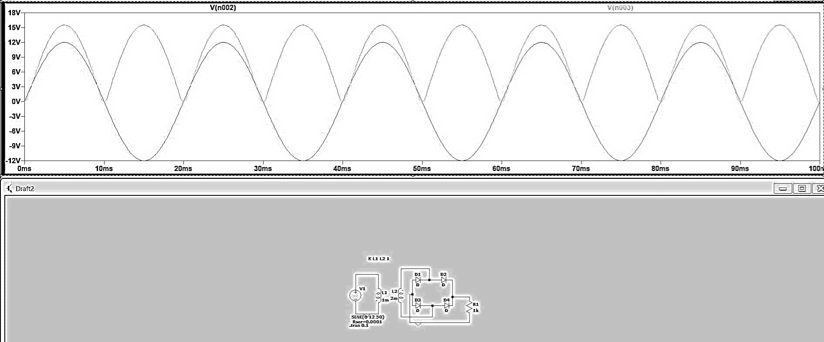

OUTPUT WAVEFORM WITH FILTER:

